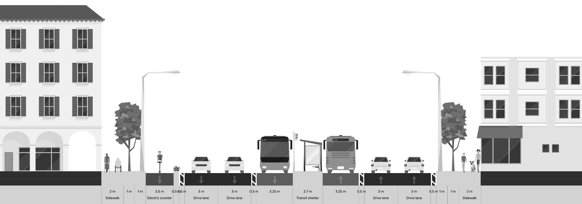

Conceptual Design and Due Diligence for the Yerevan Sustainable Urban Transport and Electric Mobility

Output 10: Parking Analysis Report (v2)

June 23, 2026
Table of Contents
1. Introduction 6
1.1 Project Background 6
1.2 Parking in the Project Context 6
1.3 Purpose and Scope of This Report 6
1.4 Relationship to the Terms of Reference 7
2 Yerevan Parking System Overview 7
2.1 Institutional and Regulatory Context of Parking Management 7
2.2 Historical Development and Nationalization 8
2.3 Regulatory Framework and Legal Authority 9
2.4 The 2024 Tariff Reform and the Resulting Legal Crisis 9
2.5 Escalation of Parking Tariffs 9
2.6 Judicial Challenges and the "Mother Armenia" Opposition 10
2.7 The "Red Line" System and Street Identifiers 10
2.8 Grace Periods and Operational Hours 11
2.9 Operational Enforcement through Mobile ANPR Technology 12
2.10 The Role of the ANPR Cameras 12
2.11 Fine Process 12
2.12 The Digital Payment Ecosystem and Financial Integration 12
3 Parking Surveys 13
3.1 Evolution of the Survey Methodology 13
3.2 Desk-Based Parking Supply Inventory 13
3.3 Reliance on Municipal Data Integration 14
3.4 Occupancy and Turnover Metrics from ANPR Data 16
3.5 Overview of Previous Field Survey Plans (Methodology) 17
4 Parking Impacts of the Conceptual Corridor Designs 17
4.1 Overview of the Conceptual Design Approach 17
4.2 Nature and Scale of Parking Removal 18
4.3 Differentiated Impacts by Land Use Context 18
4.4 Impacts on Specific User Groups 18
4.5 Alignment with Policy Framework 19
5 Displacement and Mitigation Assessment 19
5.1 Primary mitigation – the corridor itself 19
5.2 Assessment of Displacement Potential by Corridor Zone 20
5.3 International Best Practices for Displacement Mitigation 20
5.4 Yerevan-Specific Mitigation Framework 21
5.5 Mitigation Measures for Yerevan 22
5.6 Phasing and Implementation Considerations 25
5.7 Limitations and Residual Risks 25
6 Parking Management Recommendations 25
6.1 Rationale for Benchmarking in the Yerevan Context 25
6.2 Precedents and Yerevan Applicability 26
6.3 Mitigation Measure Packages by Sensitivity Zones 26
7 Conclusions (and Next Steps) 29
7.1 Key Conclusions 29
7.2 Further Studies Required 29
8 Sources 30

PROJECT SYNOPSIS

Project Name | TA-6559 REG: Implementing the Cities Development Initiative for Asia - Conceptual Design and Due Diligence for the Yerevan Sustainable Urban Transport and Electric Mobility Project (54128-001)
Country | Republic of Armenia
Geographic Area | City of Yerevan
Contract Number | S208439
Contracting Authority | Asian Development Bank (ADB)
Signed on | 26 August 2025
Commencement of service | 11 September 2025
Duration | 12 calendar months
End Date | 7 August 2026
CLient / EA | The Executing Agency (EA) is the Yerevan Municipality (YM)
PIU | The Yerevan Urban Development Programs Implementation Unit (PIU)
Funding Source | Cities Development Initiative for Asia Trust Fund, administered by ADB, through TA 6559-REG: Implementing the Cities Development Initiative for Asia approved on 8 September 2020.
Scope of Work | To develop: (i) bus public transport service Plan for Yerevan; (ii) Conceptual Design of three bus priority corridors; (iii) Upgraded depots to accommodate a fleet of battery electric buses; (iv) Traffic and Parking Management Plan; (v) Communications and Branding; and (vi) due diligence for ADB’s consideration of project financing.
Key Deliverables | Inception Report (followed by inception workshop)  Output 1: Memo describing selection of affected routes for further analysis  Output 2: Data collection methodology memo  Output 3: Raw and processed datasets for all collected data (Excel), including maps  Output 4: Network diagnostics PPT  Output 5: Service Plan PowerPoint and report, including high-quality, graphic-designed maps of the network, each route, and changes to existing routes  Output 6: Full conceptual-level designs for the bus priority corridors, bus stations, off-corridor stops, utilities, ITS, points along the off-corridor routes, and costings  Output 7: 3-D renderings of stations, with three different top structure architectural designs  Output 8: Traffic and parking surveys and analysis report  Output 9: Traffic Management Plan, including microsimulation  Output 10: Parking analysis report  Output 11: Report reviewing existing conditions at depots and future plans  Output 12: Conceptual design for both depots  Output 13: PPTs, handouts, and minutes from three public workshops  Output 14: Communication Strategy  Output 15: System brand including name and logo  Output 16: Stakeholder engagement plan  Output 17: IEE/EIA  Output 18: LARP  Output 19: Financial Management Assessment Report  Output 20: Financial Analysis Report and Linked Document  Output 21: Economic Analysis Report and Linked Document  Output 22: Strategic Procurement Plan  Output 23: Terms of reference  Output 24: Climate Risk and Adaptation Assessment  Output 25: Climate Change Assessment  Output 26: Poverty, Social and Gender Assessment Report  Output 27: Social Development and Gender Action Plan  Output 28: Institutional Assessment  Output 29: Institutional and Capacity Building Roadmap Output 30: Report on Knowledge Transfer Activities.
Consultant / Contractor | A+S Consult GmbH, Logit Consulting Inc, Exponent Engineers (Pvt.) Limited & POGHOS SHAHINYAN HAYKAZI
Contact | Team Leader: Wagner Colombini Martins, wagner.colombini@logiteng.com  Focal point: Lívia Delgado Rodrigues, livia.delgado@logiteng.com

Introduction

Project Background
The Yerevan Sustainable Urban Transport and Electric Mobility Project is being prepared with support from the Asian Development Bank to improve the efficiency, safety, and sustainability of urban mobility in Yerevan, Armenia. The project focuses on enhancing public transport performance through the introduction of bus priority corridors, upgrading supporting infrastructure, and implementing complementary traffic and parking management measures.

The conceptual designs under preparation involve the reallocation of street space along three priority corridors, including the introduction of dedicated bus lanes, improved pedestrian and non-motorised transport facilities, upgraded intersections, and associated public-realm improvements. These interventions are expected to deliver significant benefits in terms of public transport reliability, road safety, and overall corridor functionality, while requiring careful management of impacts on general traffic and parking.

Parking in the Project Context
On-street parking plays a significant role in shaping travel behaviour, curbside operations, and street performance in Yerevan. Along many arterial and mixed-use streets, parking occupies a substantial share of available curb space and often competes directly with bus operations, pedestrian movement, loading activities, and traffic flow. In several locations, informal or illegal parking practices further reduce effective road capacity and undermine safety and accessibility.

The introduction of bus priority infrastructure inevitably affects existing parking supply, both directly—through the removal or conversion of parking spaces—and indirectly, by changing traffic circulation patterns and curbside functions. If not properly assessed and managed, parking impacts can generate localised pressure on adjacent streets, affect access to businesses and residences, and create implementation risks for corridor projects.

For this reason, parking analysis is treated as a critical enabling component of the overall corridor concept. The objective is not to preserve parking at all costs, but to ensure that necessary reductions in parking supply are understood, justified, and mitigated to the extent reasonably possible, while supporting the project’s broader mobility and safety objectives.

Purpose and Scope of This Report
This Parking Analysis Report has been prepared as a standalone deliverable under Task 3: Traffic and Parking Analysis of the project Terms of Reference. It forms Output 10 of the assignment and complements the Traffic and Parking Surveys and Analysis Report (Output 8) and the Traffic Management Plan (Output 9).
The purpose of this report is to:

- Provide a clear overview of the existing parking system context along the priority corridors and in Yerevan as a whole;
- Summarise, at a strategic level, the key findings of parking surveys, without duplicating detailed survey documentation;
- Assess the impacts of the conceptual corridor designs on parking supply;
- Evaluate the potential for parking displacement within the defined influence area;
- Identify mitigation options and parking management measures that support corridor implementation; and
- Present evidence-based conclusions on the feasibility and risks associated with parking changes.

This report focuses on parking conditions in Yerevan urban area. Detailed survey methodologies, raw datasets, block-level inventories, and technical maps are documented separately and may be referenced here where relevant.
Revision note: a targeted field occupancy survey has been completed on six representative areas, on ordinary mid-week working days. Its measured results - occupancy, duration, and turnover, now underpin the impact and mitigation analysis in this report and are documented in full in the companion Traffic and Parking Surveys and Analysis Report (Output 8).

Relationship to the Terms of Reference
The content and structure of this report are aligned with the requirements set out in the project Terms of Reference, which call for:
- Documentation of on-street and off-street parking supply;
- Evaluation of parking loss resulting from corridor redesign;
- Analysis of parking displacement and mitigation options; and
- Preparation of a parking analysis report to support decision-making.

By focusing on interpretation, impacts, and management implications rather than survey execution, this report is intended to support informed discussion with the Yerevan Municipality and other stakeholders on how parking can be managed in a manner consistent with the project’s transport, safety, and urban-realm objectives.

Yerevan Parking System Overview
The urban landscape of Yerevan, the capital of Armenia, has encountered a transformative decade in terms of its transport infrastructure and public space management. As the city has grown in both population and vehicle density, the management of on-street parking has transitioned from an informal, often chaotic arrangement into a highly regulated, technology-driven municipal service. This report serves as a foundational analysis of the current parking ecosystem, evaluating the institutional framework, the socio-economic implications of recent fiscal reforms, and the technical mechanisms of enforcement and data-driven management. By examining the evolution of "Parking City Service" CJSC and the broader regulatory environment, this analysis identifies the critical pressure points in Yerevan’s urban mobility strategy and provides a robust framework for understanding the city's transition toward a "smart city" model of metropolitan governance.

Institutional and Regulatory Context of Parking Management
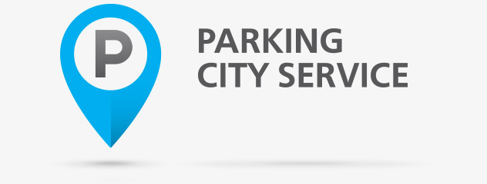
The governance of parking in Yerevan is anchored in a centralized municipal structure that has undergone significant shifts in ownership and operational philosophy. At the center of this structure is the "Parking City Service" Closed Joint-Stock Company (CJSC), which operates as a specialized utility under the jurisdiction of the Yerevan Municipality. The establishment of this entity was a direct response to the increasing congestion in the city’s administrative districts, particularly the Kentron (Center) and Arabkir areas, where the competition for limited street space had begun to impede the flow of public transit and emergency services.
Figure 1, „Parking City Service“ CJSC / www.pcs.am

Historical Development and Nationalization
The operational history of "Parking City Service" is characterized by its transition from a private enterprise to a nationalized municipal asset. Originally launched in 2013 as a private company, the service was tasked with introducing the "red line" system—a series of designated paid parking zones identified by red pavement markings. The initial private management model was designed to leverage private capital for the installation of video monitoring equipment and the development of a digital payment infrastructure. However, the private operation of public space quickly became a focal point of political and social tension. Questions emerged publicly regarding the distribution of parking revenue between the private operator and the municipality, as a significant portion of the fees and fines collected were retained by private operators rather than being reinvested into the city's general budget.
In late 2016, following a municipal policy decision to bring parking management into direct public administration, the Yerevan Municipality initiated the nationalization of "Parking City Service". The company's ownership was transferred to the city, allowing for a more transparent integration of parking revenue into the municipal transport budget. This institutional shift was not merely a change in ownership but a fundamental change in mission; the service moved from a profit-driven model to a public utility model where parking regulation is viewed as a tool for urban mobility management rather than a simple revenue stream.
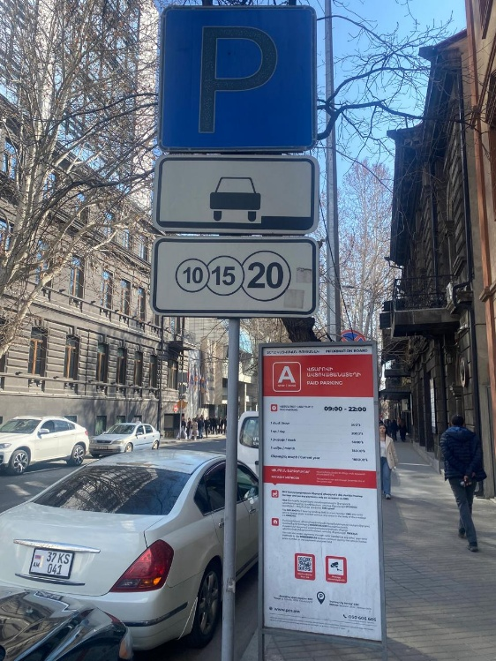

Figure 2, On-Street Parking on M.Khorenatsi Street

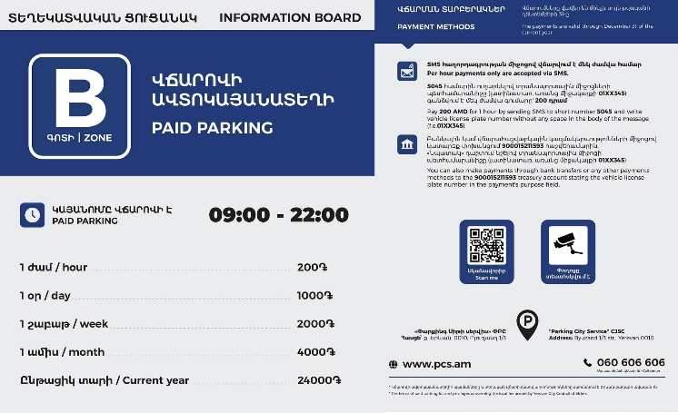
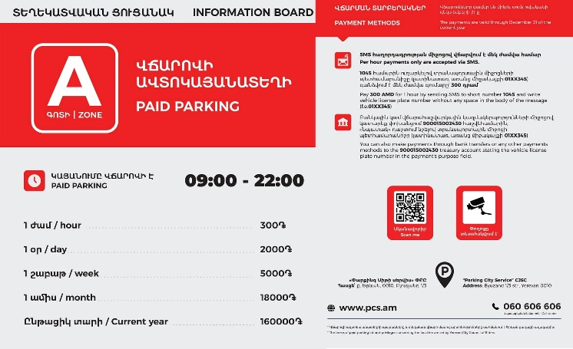
Figure 3, Information Boards for Zone A - Red Line, Zone B - Blue Line

Regulatory Framework and Legal Authority
The legal basis for parking regulation in Yerevan is derived from the Armenian law "On Local Parking Fees for Motor Vehicles". This legislation empowers the Yerevan Council of Elders—the city's primary legislative body—to establish parking zones, set fee structures, and define the parameters of enforcement. The Council of Elders acts as the governing board for municipal policy, frequently debating the balance between fiscal necessity and public affordability.
Under this framework, "Parking City Service" CJSC is responsible for the technical implementation of these policies. Its mandate includes the maintenance of road markings, the operation of the automated Automatic Number Plate Recognition (ANPR) camera network, and the management of the digital back-office that processes parking sessions.
The Director of the CJSC, Van Tadevosyan, oversees these operational functions, ensuring that the service aligns with the broader goals of the Municipality’s Transport Department. On February 24, 2026 an private interview with Mr. Tadevosyan at his workplace was conducted. Parts of this report are based on his responses throughout the aforementioned meeting.

Regulatory Entity | Primary Responsibility | Legal Basis
Yerevan Council of Elders | Legislative oversight, fee setting, and zone designation. | RA Law "On Local Parking Fees for Motor Vehicles".
Yerevan Municipality Transport Dept. | Strategic coordination with public transit and road police. | Municipal Charter.
"Parking City Service" CJSC | Operational execution, ANPR enforcement, and pavement marking. | CJSC Corporate Charter and Municipal Contracts.
RA Road Police | Administrative adjudication of traffic and parking violations. | RA Administrative Code.

This institutional arrangement ensures that parking policy is integrated into the city's wider economic and transport goals. For example, the decision to exempt electric vehicles from parking fees was not merely a parking policy but a strategic move by the Council of Elders to promote green mobility within the capital.

The 2024 Tariff Reform and the Subsequent Legal Proceedings
One of the most significant developments in the recent history of Yerevan's parking management is the comprehensive tariff reform implemented on January 1, 2024. This reform represented a dramatic departure from the previous uniform pricing model, introducing a highly stratified system of zones and fees designed to use economic levers to manage congestion in the city center.

Escalation of Parking Tariffs
Prior to 2024, the annual fee for parking in Yerevan's "red zones" was a flat rate of 12,000 AMD, regardless of location or usage frequency. This low cost resulted in consistently high occupancy in the city center, as commuters found it more economical to park on the street than to utilize public transit or off-street facilities. The 2024 reform introduced a two-tiered system—Zone A and Zone B—with pricing that reflects the varying demand for space in different administrative districts.
In Zone A, which covers the most congested parts of the Kentron district, the annual fee was increased from 12,000 AMD to 160,000 AMD, representing an escalation of over 1,200%. Zone B, covering less intensive areas, saw a more moderate increase to 24,000 AMD per year. The hourly rates were also adjusted to 300 AMD in Zone A and 200 AMD in Zone B, creating a pricing structure that encourages short-term turnover over long-term occupancy.

Duration of Stay | Zone A Tariff (2024-2026) | Zone B Tariff (2024-2026)
1 Hour | 300 AMD | 200 AMD
1 Day | 2,000 AMD | 1,000 AMD
1 Week | 5,000 AMD | 2,000 AMD
1 Month | 18,000 AMD | 4,000 AMD
1 Year | 160,000 AMD | 24,000 AMD

The rationale provided by the municipality for these increases was twofold: to generate revenue for the modernization of the public transport fleet and to "unload" the streets of the city center by discouraging unnecessary private vehicle travel. By increasing the cost of parking to a level that reflects the market value of urban space, the city aimed to force a modal shift toward buses, trolleybuses, and the metro.

The "Red Line" System and Street Identifiers
The effectiveness of Yerevan's parking system is physically defined by the red and blue line markers and the associated signage that governs the city’s streets. The spatial distribution of these zones reflects a strategic effort to manage high-demand corridors while maintaining accessibility for residents and local businesses.
The lines red, blue and yellow (indicating that parking is prohibited in the area) are the primary visual cue for motorists in Yerevan. These markings indicate that a specific segment of the street is subject to local parking fees during operational hours. The maintenance of these lines is a continuous operational task for "Parking City Service," as weather conditions and heavy traffic flow frequently obscure the markings, leading to potential disputes over the legality of citations.
Complementing the pavement markings are standardized road signs and information boards. These boards are critical for informing drivers about the zone classification (A or B) and the available payment methods, including the specific short-codes for SMS billing.
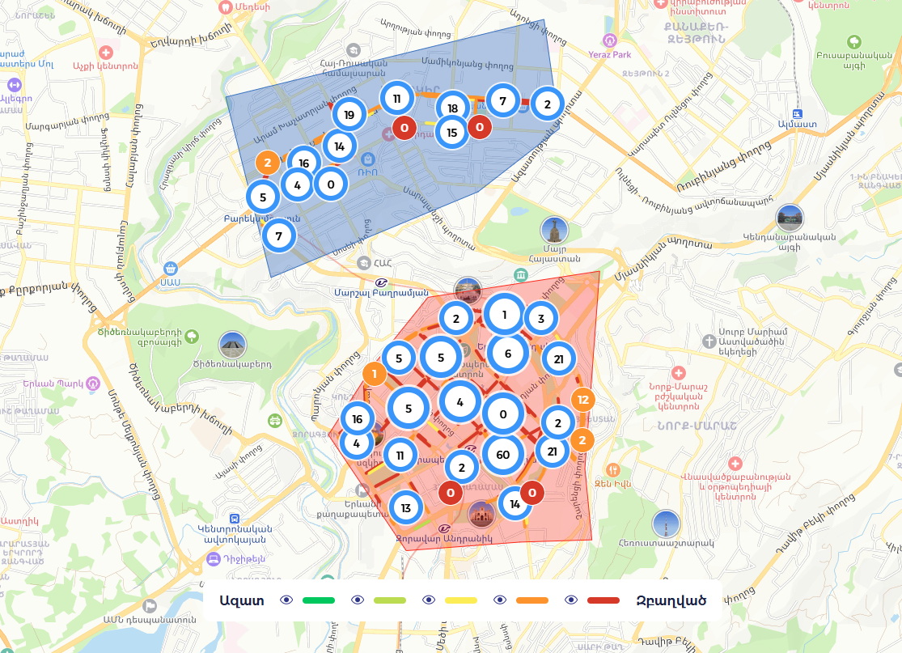
Figure 1 - Parking map available on www.pcs.am website

Grace Periods and Operational Hours
A vital feature of the Yerevan parking system is the 15-minute grace period. This period is designed to facilitate quick commercial activity—such as dropping off passengers, loading goods, or making short deliveries—without requiring the driver to engage in the payment process. This allowance is particularly important for the city's small commercial operators and delivery services, which rely on quick access to storefronts. Although, the role of the 15-minute grace period may warrant periodic review as the system matures. It’s typical for cities to offer public-friendly features as this one when introducing new parking systems in the beginning, but when the reform and system mature, it could be argued that the grace period does not serve the system.
Standard operational hours for the paid parking system are from 09:00 to 22:00. Outside of these hours, parking is free of charge. This policy recognizes that the demand for street space changes significantly at night, and the primary goal of the parking fee—congestion management—is less relevant during the late-night and early-morning hours. However, motorists must ensure their vehicles are either removed or paid for by 09:00 to avoid automatic citations generated by the cameras.

Operational Enforcement through ANPR Technology
Enforcement in Yerevan has evolved from manual ticket-writing by controllers to a sophisticated, automated system built on a fixed network of Automatic Number Plate Recognition (ANPR) cameras. This transition has significantly increased the efficiency of enforcement while reducing the potential for human error and improving procedural consistency.

The Role of the ANPR Cameras
"Parking City Service" operates ANPR cameras mounted on poles along the street. These cameras surveil the designated parking zones, capturing the licence plates of every vehicle parked. Enforcement runs entirely through this fixed camera network: a parked vehicle is detected by the camera covering its zone, its plate is matched against the payment record held in the back-office, and a citation is issued from there if no valid session is found. That chain — fixed camera, back-office match, citation — is the complete mechanism by which a parking violation is established in Yerevan.
When a camera scans a license plate, the data is immediately transmitted to a central server where it is cross-referenced with a database of payment records. If no payment is found for a particular vehicle, the system records the location and timestamp. The camera system accounts for the grace feature, a violation is only finalized after the 15-minute period.

Fine Process
Once a violation is confirmed by the "Parking City Service" back-office, the data is shared to the driver via SMS, post, banking app. The standard penalty for failing to pay the local parking fee is 5,000 AMD.
Camera captures violation → information processed → notification sent via multiple channels (SMS, post, banking app) → fine goes to State Treasury. If the driver still does not pay, the case goes to court to find the owner. The system tracks parking duration through camera timestamps (entry and exit captured). Cameras are linked to police database for vehicle owner identification. Foreign/tourist vehicles without registration may escape fines. When a fine is sent, a video of the violation is included as evidence. The car owner (not driver) is liable.
If the fine is not paid and the vehicle becomes subject to towing, the process is handled by the Police, not the “Parking City Service”.

The Digital Payment Ecosystem and Financial Integration
The modernization of Yerevan's parking system is heavily dependent on its digital payment infrastructure. The city has prioritized a "cashless" model, integrating parking fees into the broader financial technology landscape of Armenia.
SMS remains one of the most popular methods for short-term parking payment in Yerevan. By texting their license plate number to the short-codes 1045 (Zone A) or 5045 (Zone B), drivers can initiate an hourly parking session. The cost is deducted directly from their mobile balance or added to their monthly bill.
For those who do not wish to use SMS, or for those paying for daily, monthly, or annual subscriptions, a vast network of payment terminals and mobile applications is available.
- Payment Terminals: Devices operated by Telcell, EasyPay, and Idram are ubiquitous in Yerevan, found in most grocery stores, bus stops, and public buildings. These terminals allow for cash or card payments directly into the "Parking City Service" account.
- Mobile Apps: Applications like iDram and Mobidram allow users to manage their parking sessions from their smartphones, providing the ability to extend sessions remotely and track payment history.
- Online Portals: The Yerevan Municipality website (yerevan.am) offers an electronic service portal where residents can pay their annual fees and check for any outstanding parking debts using their vehicle registration data.
This multi-channel payment ecosystem is designed to minimize the "barrier to entry" for legal parking. By providing numerous ways to pay, the municipality reduces the validity of the excuse that a driver was "unable" to make a payment before the camera recorded the vehicle.
One of these subscription options is a flat annual zonal-parking permit, bought once for unlimited use of a parking zone for the year. Because a flat annual fee removes the marginal cost of each additional hour parked, it works against the kerb turnover the corridor strategy depends on. This report recommends withdrawing it in favour of hourly, occupancy-based pricing and a charged resident permit; the measure, and the Parking City Service permit data needed to phase it, are set out in the mitigation-measures chapter.
During our conversation with the head of PCS, the near future plans of rolling out a mobile app for parking has been revealed. Yerevan will soon have a parking app where drivers will be able to see the parking places on a map, check for available spaces and pay for the parking via the app.

Parking Surveys

Evolution of the Survey Methodology
The original requirements set out in the Project Terms of Reference (ToR) called for a full-scale, corridor-wide field survey to document parking supply and occupancy. However, following multiple rounds of technical discussions, iterative revisions of the methodology paper, and the receipt of successive financial proposals from local survey companies, it became clear that such a comprehensive field operation was not feasible within the available resources and project timeframe.
In response, the project team, in close coordination with local experts and the Project Implementation Unit (PIU), refined the approach to prioritize a desk-based parking supply inventory. This refined strategy abandons manual field observations in favor of high-resolution digital tools and the integration of existing state-owned databases.

Desk-Based Parking Supply Inventory
The primary component of our data collection is a comprehensive supply inventory developed through a systematic "desk job". This inventory utilizes 360-degree street videos collected during project field missions, supplemented by recent street-level imagery and existing municipal maps.
The objective of this inventory is to map and geo-reference every on-street parking space, including:
- Physical Geometry: Parking orientations (parallel, 45-degree, or perpendicular).
- Regulatory Status: Documenting "red-line", "blue-line", and free parking zones.
- Off-Street Context: Cataloging major off-street facilities on the priority corridors to evaluate their potential to absorb displaced demand.
https://yerevan-parking.vercel.app/The parking assessment for Yerevan was based on a desk-based parking supply inventory covering the bus priority corridors with a 100-metre influence area. Across Corridors 1 and 2 the survey identified 14,557 parking spaces, including 6,095 on-street spaces on the corridors themselves, 1,730 on-street spaces on adjacent cross-streets, and 6,732 off-street spaces in yards and lots. Corridor 3 is withheld from the assessment pending its conceptual design; for the record the inventory found a further 896 on-corridor spaces along it. This broader survey frame matters because the project is concerned not only with the parking currently on the corridors but also with the nearby streets and off-street spaces that may absorb part of the impact once the corridor designs are implemented.
The survey results show that the existing parking system along the corridors is dominated by unregulated supply. Of the on-corridor spaces, 5,248 (86.1%) are free, while only a relatively small proportion fall within Zone A (246 spaces), Zone B (534 spaces) or designated taxi spaces (67). The physical organisation of parking is also weak: only 20% of corridor parking has signage, only 14% has markings, and about 76% is parallel parking. These findings indicate that a large share of the existing parking supply is poorly structured and not managed in a systematic way.
When the supply inventory was compared with the conceptual corridor designs, the scale of impact became clear. On the v2 design the corridors would remove 4,875 of the 6,095 on-corridor spaces while 1,220 would be retained or re-established, meaning that around 80% of current corridor parking would be removed. This is a substantial change, but it should be interpreted carefully. Even though all Zone A corridor spaces would be removed, their share in relation to the total Zone A parking supply in the city remains limited. Equally important, the cross-street and yard inventory demonstrates that the corridor itself is not the only location where parking can be managed or reorganised. These figures follow the current conceptual design and will be updated when it is final.
Overall, the survey confirms three key points. First, the project corridors currently contain a large amount of parking supply, much of it free and weakly managed. Second, the planned bus priority design will significantly reduce this supply on the corridor itself. Third, the surrounding street network and off-street yards may provide a basis for mitigation, meaning that the task is not simply to count removed spaces, but to understand how demand can be redistributed and better managed within the wider corridor area. This is the main analytical value of the survey.

Field Occupancy Survey
While supply is relatively static, occupancy is highly dynamic.
Metric | Definition | Importance for Yerevan
Occupancy Rate | The percentage of theoretical capacity currently in use. | Identifies zones where demand exceeds the "85% rule" of efficiency.
Duration of Stay | The average time a unique plate is detected in a single location. | Distinguishes between "commuter" parking and "retail" turnover.
Turnover Rate | The number of different vehicles utilizing a single space over a 24-hour period. | Measures the economic vitality of commercial streets.
Violation Rate | The ratio of undetected/unpaid plates to total detected plates. | Evaluates the enforcement effectiveness and the level of public compliance.
The target occupancy for on-street parking is generally considered to be 85%. At this level, the street is being utilized effectively, but there is still a 15% vacancy rate—meaning one in every seven spaces is empty. This ensures that an arriving driver can find a spot without "cruising," which is a major contributor to urban congestion and emissions.
A field occupancy survey was carried out on six representative areas (Kentron, Komitas, Gai Avenue/Mega Mall, Garegin Nzhdeh, Shiraz/Hasratyan and Malatia-Sebastia) rather than the full corridor, on four separate ordinary working days between 29 May and 3 June 2026. Enumerators made hourly licence-plate sweeps from 07:00 to 24:00, recording for every parked vehicle the hour, the zone, the plate, the vehicle type, the kerb location, the parking method and the legality — 21,186 on-street sightings of 10,135 distinct vehicles across 136 survey zones, plus one off-street facility per area. The measured results are summarised in this report; the full methodology, the survey locations and the results broken down by area are set out in the field occupancy survey chapter of the companion Traffic and Parking Surveys and Analysis Report (Output 8).
The survey was designed to establish an evidence-based baseline for kerbside use to inform the design of the bus priority corridors, capturing both formal red-line areas and free parking practice. The Parking Survey Methodology (v. 18052026) set out three defining features, all of which were executed: a 17-hour observation window (07:00 to 24:00) covering the full daily cycle of commuter and residential activity; manual licence-plate recording, which is what makes turnover and duration measurable rather than estimated; and systematic logging of parking that encroaches on footways, bus stops and second lanes. The one element that could not be delivered was payment compliance, which is observable only in the Parking City Service back-office.

Parking Impacts of the Conceptual Corridor Designs

Overview of the Conceptual Design Approach
The conceptual corridor designs developed under Task 2 of the project represent a fundamental reallocation of street space. Along much of the alignment the dedicated bus lanes run in the central median, consistent with international best practice for bus rapid transit as endorsed by the ITDP BRT Standard and the European BHLS (Buses with High Level of Service) framework; along other sections they run kerbside. It is worth being precise about what follows from that choice, because it is easy to attribute the parking loss to the median alignment. A kerb-aligned bus lane occupies the very kerbside space that parking occupies, and so removes as much on-street parking as a median-aligned one; the difference between the two is where passengers board, an island platform in the carriageway rather than a stop on the footway, not how much parking survives. The parking impact follows from reallocating the full right-of-way to bus lanes, general traffic, cycle lanes and adequate footways. That reallocation, not the alignment, is what carries direct and significant consequences for the existing on-street parking supply along both corridors.
The cross-sections developed by the design team allocate the available carriageway width to dedicated bus lanes (2 x 3.5 m), mixed-traffic lanes (2 x 3.0 m per direction), median platforms and separators (0.5 m buffers), and minimum sidewalk widths of 2.50 m on each side. In station areas, additional width is required to accommodate 18-metre platform structures, turnstiles and bike parking facilities. Where the existing right-of-way is fully consumed by that allocation, no kerbside parking can be retained, and this is the case along most of the alignment. Between stations, however, the cross-section is less demanding and in most such sections there is room for parking to remain. That is why the design retains or re-establishes 1,220 spaces (20% of the on-corridor supply) rather than removing all of it.

Nature and Scale of Parking Removal
The conceptual designs remove on-street parking along almost the entire length of the corridors — 80% of the on-corridor supply, with roughly 1,220 spaces retained off the carriageway. This outcome is not incidental but inherent to the design philosophy: the bus lanes, combined with the requirement for cycle lanes, widened sidewalks and landscaped curb extensions between every three to four retained off-corridor parking spaces (as specified in the Terms of Reference), occupy the entirety of the available right-of-way. This is consistent with the policy direction established in the 2022 Mott MacDonald Parking and Taxi Management Strategy, which explicitly states that parking will not be permitted on streets with strategic bus routes, as the space is required for bus lanes, cycle lanes and bus stops.
The scale of parking loss is substantial. Based on the 360-degree video supply inventory conducted as part of the parking surveys (detailed separately in the Traffic and Parking Surveys Report, Output 8), the three corridors combined currently accommodate a significant volume of formal and informal on-street parking. The parking that will be removed includes designated red-line paid parking spaces managed by Parking City Service CJSC, free parallel and echelon parking that has developed in the absence of enforcement, and informal off-carriageway parking on footpaths and at bus stops that currently degrades pedestrian and bus operations. The field survey found about 21% of vehicles parked off the carriageway (14.3% on footpaths, 6.7% in setbacks), while overt illegal parking was negligible (about 0.2%) — the kerbside issue is tolerated informality and saturation rather than overt illegality.

Differentiated Impacts by Land Use Context
The impact of parking removal varies significantly depending on the land-use context of each corridor segment. In the Kentron (Centre) district, where sections of Corridor 1 pass through Zone A of the current parking tariff system, on-street parking serves a mix of short-term commercial visitors, delivery and loading operations, and long-stay commuter parking. The 2024 tariff reform, with its 300 AMD hourly rate for Zone A, was specifically designed to encourage turnover and discourage all-day occupancy. The removal of parking from these central segments will disproportionately affect short-term visitors and loading operations, while the displacement of commuter parking is arguably aligned with the project objectives of modal shift toward public transport.
In residential segments of Corridor 2, particularly through the Nor Nork and Malatia-Sebastia districts, the parking that will be removed is predominantly used for overnight residential storage. It should be said plainly that these areas are not without parking. Aerial imagery and the field survey both show substantial parking between the blocks: along the internal streets, on setbacks and hard standing, and in the sheds and lock-up garages that occupy parts of the courtyards. Malatia-Sebastia in fact records the lowest daytime kerb pressure of the six surveyed areas (54% peak) and the highest share of parking standing off the carriageway (30.9%). The accurate statement is not that parking is absent but that formal, allocated provision per dwelling is low: the Soviet-era blocks were laid out before mass car ownership, so what exists is informal and unmanaged rather than designed. It should also be noted that the Corridor 2 alignment through Nor Nork runs at some distance from the housing estates themselves, so the parking directly removed there is largely arterial kerbside parking rather than the residents' own courtyard parking. The risk to manage is therefore displacement pressure arriving in those courtyards, not the loss of a provision the estates never had.
Along Arshakunyats Avenue, the wide right-of-way (typically exceeding 30 metres) has historically accommodated multiple lanes of traffic alongside parking. The conceptual design uses this width to provide a comprehensive cross-section including bus lanes, two mixed-traffic lanes per direction, cycle lanes and generous sidewalks. The width is largely consumed by that allocation, but not entirely: Arshakunyats retains parking in the sections where the right-of-way allows, and Corridor 1 as a whole retains 869 of its 2,349 on-corridor spaces. The earlier draft's statement that the design precludes the retention of any on-street parking along this avenue overstated the position and is corrected here.
The field survey confirms and quantifies these differences. The Kentron commercial core runs at 138% peak occupancy and is short-stay dominated (about 63% of vehicles stay one hour or less). The Malatia-Sebastia residential segment shows the lowest daytime pressure (54% peak) but the strongest long-stay / overnight signature, consistent with residential storage rather than turnover. Turnover across the surveyed areas runs at 3.5 to 7.5 vehicles per space per day.

Impacts on Specific User Groups
The removal of corridor parking affects several distinct user groups, each with different levels of sensitivity and adaptability. Residents along the corridors, particularly in areas without private garages or courtyards, face the most direct impact. Their parking needs are typically for long-duration overnight storage and are least easily served by alternative locations. Commercial businesses that depend on customer access by car, such as retail shops, restaurants, and medical offices along the central sections, may experience reduced footfall if customers perceive parking as unavailable, although European experience with bus corridor implementation suggests that improved public transport access and enhanced streetscape quality ultimately benefit commercial activity.
Delivery and loading operations represent a critical functional requirement that persists regardless of parking policy. The removal of curbside parking eliminates the informal loading zones that many businesses currently rely upon. The conceptual designs accordingly provide designated loading bays at commercial concentrations along both corridors: this is a design requirement agreed between the parking and corridor design teams, not a recommendation made to them, and the bay locations are being fixed as the design is detailed. The field survey sizes that provision, since freight presence is concentrated rather than uniform: the truck share of classified vehicles reaches 12.6% in Malatia-Sebastia and 8.0% in Shiraz/Hasratyan against 4.9% across the six areas, so bays should be concentrated in those pockets. Taxi operations, currently informal along much of the corridor network, also require designated pick-up and drop-off facilities, particularly near stations and commercial concentrations.
Persons with disabilities who depend on proximate parking access are a particularly vulnerable group. Armenian law and international accessibility standards require that accessible parking be maintained within reasonable proximity to key destinations. The corridor designs must ensure that accessible parking provision is specifically addressed, either through retained on-street spaces at designated locations or through clearly marked accessible parking on immediately adjacent side streets.
Measured user groups (field survey). The survey lets these groups be anchored to observed behaviour rather than assumption. Visitors and customers are the dominant group (about 63% of vehicles stay one hour or less, 77% two hours or less). Commuters and workers are a small all-day tail (around 6%), better addressed as a BRT mode-shift opportunity than as a fining target. Residents appear as an overnight share (about 7%) that the daytime window under-counts and that should be protected, not weakened. Delivery and freight show as a measurable truck presence concentrated in pockets — truck share, calculated as trucks divided by all classified vehicles surveyed in the area, reaches 12.6% in Malatia-Sebastia (548 of 4,339 vehicles) and 8.0% in Shiraz (198 of 2,469), against 4.9% across all six areas — so loading provision should be sized to those pockets rather than uniformly. Taxi and persons-with-disabilities provision is retained by design.

Alignment with Policy Framework
The removal of on-street parking from the bus priority corridors is fully consistent with the strategic policy direction established for Yerevan. The Yerevan Sustainable Urban Transport Strategy adopts a modal hierarchy in which sustainable transport modes take priority, and explicitly states that road space on strategic streets will be prioritised for moving people in sustainable transport and not for parking cars. The 2022 Mott MacDonald Parking and Taxi Management Strategy similarly identifies that the roll-out of new priority bus infrastructure will see the removal of some existing parking spaces on certain streets, and recommends that parking provision be withdrawn from streets along which strategic bus services operate.
At the national level, the Government of Armenia, through its collaboration with the Asian Development Bank, has signalled a clear commitment to sustainable urban transport. The Terms of Reference for the current project explicitly anticipate that the development of bus priority corridors may impact parking supply and require the Consultant to evaluate options for displaced parking. The parking removal is therefore not an unintended consequence but a planned and necessary element of the corridor transformation.

Displacement and Mitigation Assessment

Primary mitigation – the corridor itself
Parking displacement refers to the relocation of parking demand from the corridor to adjacent streets, off-street facilities, or alternative modes of access when on-street supply is removed. The degree to which displacement occurs, and whether it creates problems, depends on several factors: the volume of parking removed relative to surrounding capacity, the availability and proximity of alternative parking locations, the willingness and ability of users to adjust their behaviour, and the management measures put in place to absorb and redirect demand.
International experience with bus priority corridors in European cities demonstrates that the actual level of displaced parking that needs to be physically accommodated is typically lower than the number of spaces removed. This is because a significant proportion of users shift to other modes (particularly the improved public transport that the corridor provides), adjust their trip timing or destination, or were previously engaged in illegal or informal parking that should not be replicated elsewhere. The European BHLS (Buses with High Level of Service) experience, documented through projects in Nantes, Metz, Rouen, Eindhoven, Helsingborg, and other cities, consistently shows that well-implemented bus priority corridors generate net positive outcomes for corridor liveability and commercial viability, even where substantial parking removal was required.
In other words, the bus priority corridors are themselves the primary mitigation: by delivering faster, more reliable public transport they reduce the mode share of private cars, and so the number of vehicles needing to park. Some users shift modes, some adjust trip timing, and some no longer park on the corridor at all. Every other measure in the chapters that follow complements that structural shift.
How much car travel the corridor absorbs. International experience indicates that the corridor itself absorbs a real but modest share of private-car travel, and that the size of that share depends on what the BRT replaces. Rider surveys on European and North American corridors report that between 5% and 29% of passengers previously made the same trip by car; Istanbul's Metrobus, the nearest regional comparator, recorded 4 to 9% five years after opening. Where BRT is built over an existing dense bus or minibus network, however, the figure falls to the low single digits: 9% in Bogota, 4% in Lagos and Lahore, 1.4% in Guangzhou, and effectively zero in the surveyed Soweto corridor of Johannesburg, because the great majority of riders transfer from services they were already using rather than from cars. Yerevan's corridors follow existing high-ridership public-transport spines and should therefore be planned on the lower assumption. This is consistent with the field survey, which found that genuine all-day commuters — the trips a BRT is best able to absorb — account for only about 6% of observed kerb parking, against 63% staying one hour or less. Modal shift should accordingly be treated as a gradual, second-order contribution to relieving parking pressure rather than as a substitute for the parking measures proposed here; the case for the kerb reallocation rests on the directly measured finding that peak displaced demand equals only 59% of the spaces removed.

Assessment of Displacement Potential by Corridor Zone
The displacement assessment considers three categories of corridor segments, differentiated by the severity of the parking pressure and the availability of mitigation options.
High-sensitivity zones include the central sections of Corridor 1 through the Kentron district, where parking demand is intense and the side streets are themselves under significant parking pressure, together with Komitas Avenue. In these areas the potential for simple displacement to adjacent streets is limited and more comprehensive management interventions are required. The Amiryan, Nalbandyan and Tigran Mets segments fall into this category, as does Komitas Avenue, which the field survey moved here from the medium band: it runs at 123% peak occupancy with 0% of its displaced demand re-absorbable on nearby streets, which is high-sensitivity behaviour on both measures. Komitas also carries 522 of the 534 Zone B spaces on the corridors, so it is the single largest block of priced kerb affected.
Medium-sensitivity zones encompass corridor segments where parking demand is moderate and some absorptive capacity exists on parallel or perpendicular streets within 100 metres. The mid-sections of Arshakunyats Avenue, the Kievyan segment and Garegin Nzhdeh fall into this category. Here, managed displacement to side streets, combined with improved delineation and enforcement, can accommodate a meaningful share of the removed parking demand.
Lower-sensitivity zones include the outer sections of all three corridors. In these areas, the surrounding street network typically has greater spare capacity, lower existing occupancy, and a more suburban character that permits more flexible parking accommodation. Displacement in these zones is less likely to generate significant conflict.
Measured recalibration (field survey). The survey tests these a-priori labels against behaviour. Kentron is confirmed high-sensitivity (138% peak) but for an off-street-led reason: only about 10% of its displaced demand can be re-absorbed on nearby streets. Komitas, previously medium, behaves as high-sensitivity (123% peak, 0% on-street absorption) and is reclassified accordingly throughout this report. Shiraz/Hasratyan and Malatia-Sebastia behave as genuinely lower-sensitivity (75% and 54% peak). Gai Avenue is the one exception: even filling every nearby off-street yard to capacity leaves a residual with nowhere to go (123% peak). So the kerb parking simply stays for now, and gets a fresh look later as the area changes, when new facilities become available or the planned BRT line arrives. Across the surveyed areas, peak displaced demand was 1,120 vehicles against 1,886 spaces removed (59%) — that is, the distinct vehicles counted in the removed zones at each area's busiest hour, set against the capacity removed in those same zones — confirming with local measurement that displaced demand falls well below the supply removed.

International Best Practices for Displacement Mitigation
European cities that have implemented bus priority corridors and BHLS systems have developed a range of proven strategies for managing parking displacement. These strategies are not applied in isolation but as integrated packages tailored to local conditions. The following synthesis draws primarily on European experience, supplemented by relevant examples from other regions where applicable to the Yerevan context.
Controlled Parking Zones (CPZ) on adjacent streets represent the single most important mitigation tool available. When on-street parking is removed from a bus corridor, the demand pressure shifts to neighbouring streets. Without management, this leads to uncontrolled overflow parking that creates conflict with residents and degrades the local environment. The introduction of zone-based residents parking permits, time-limited visitor parking, and appropriate enforcement on streets within the corridor influence area (typically 100-200 metres from the corridor) ensures that displaced demand is absorbed in an orderly manner. Cities such as London, Paris, Amsterdam, Barcelona, Bologna, and Tbilisi have all adopted zoned parking controls as a core element of their urban transport management, with the 2022 Mott MacDonald Parking Strategy for Yerevan recommending a similar approach.
Conversion of informal to formal parking on side streets is a particularly relevant measure for Yerevan, where significant numbers of vehicles park informally or illegally on sidewalks, in unmarked areas, and in configurations (perpendicular and echelon) that use street space inefficiently. By surveying side streets within the 100-metre influence area and formally delineating parallel parking spaces with clear markings, landscaped curb extensions, and appropriate signage, the effective supply of regulated parking can often be increased even as corridor parking is removed. The Terms of Reference specifically call for the Consultant to design structured parking spaces for parking that remains both on- and within 100 metres off-corridor, with landscaped curb extensions between every three to four spaces.
Demand management through pricing represents a powerful tool for reducing the total volume of parking that needs to be accommodated. Yerevan already has the institutional framework for demand-responsive parking pricing through the Parking City Service CJSC and the 2024 tariff reform (Zone A at 300 AMD/hour, Zone B at 200 AMD/hour). By extending or adjusting parking pricing on side streets that receive displaced demand, the municipality can discourage long-stay commuter parking and encourage turnover, freeing spaces for short-term users who genuinely need proximate access. The Mott MacDonald strategy explicitly recommends that parking fees use an hourly rate only, with all period-based fees withdrawn, and that pricing should be set higher than the cost of using public transport on a daily basis.
Designated loading and servicing zones must be integrated into the corridor design to accommodate the essential functions that on-street parking currently serves. European experience, as codified in the NACTO Global Street Design Guide, demonstrates that purpose-based curbside zones combining time-limited loading bays, taxi stands, and short-stay drop-off areas can serve commercial access needs far more efficiently than unmanaged on-street parking. These zones should be located at strategic intervals along the corridor, typically near commercial concentrations, and should be enforced through time restrictions and, where available, ANPR camera monitoring.
Park-and-ride at peripheral stations is a strategy often used to intercept car trips before they reach congested central sections, and the 2022 Mott MacDonald strategy recommends it for Yerevan in general terms. It is not carried forward as a measure in this report: the conceptual design for these corridors does not include park-and-ride facilities, and the field survey gives no support for prioritising it, since the daytime kerb is overwhelmingly short-stay (about 63% of stays are one hour or less and only about 6% are all-day commuter parking) and park-and-ride addresses precisely the all-day commuter trip that is the smallest component of measured demand. It is therefore recorded here as considered and not recommended.
Modal shift facilitated by improved public transport is, in many ways, the most significant displacement mitigation measure of all. The bus priority corridors themselves represent a transformative improvement in public transport quality, offering faster, more reliable, and more comfortable service. International evidence from European BHLS implementations consistently shows that a meaningful proportion of former car users shift to improved public transport when it offers competitive journey times and reliable service. The BRT corridor planning guide published by ITDP notes that in corridors where bus rapid transit has been successfully implemented, a reduction in general traffic demand often materialises, which itself reduces parking pressure. The Yerevan project, by providing dedicated bus lanes, modern electric buses, and upgraded stations, creates the conditions for precisely this type of mode shift.

Yerevan-Specific Mitigation Framework
Applying the international best practices to the Yerevan context requires careful consideration of the city-specific conditions that shape the feasibility and effectiveness of each measure. Several factors distinguish Yerevan from typical Western European cities and must be accounted for in the mitigation strategy.
First, the existing enforcement capacity, while significantly enhanced by the ANPR camera system operated by Parking City Service, is still developing. The effectiveness of zoned parking controls and time-limited loading bays depends directly on the ability to enforce them. The ANPR control that currently operates provides a strong foundation, but its coverage would need to extend to the side streets that absorb displaced parking. The planned mobile parking application, discussed in the meeting with the PCS Director, would further support enforcement by enabling digital monitoring of parking sessions on newly regulated streets.
Second, the legal and political context around parking in Yerevan is unusually complex. The ongoing judicial challenges to the 2024 tariff reform, the court rulings questioning the empirical basis for parking price increases, and the general political sensitivity around parking charges all constrain the speed and scope with which new parking management measures can be introduced. Any mitigation strategy must be designed to be implementable within the current legal framework or with minimal legislative change, and must be supported by the data-driven evidence that the courts have indicated is necessary.
Third, the urban form of much of Yerevan, particularly the residential areas served by Corridor 2, means that on-street management alone cannot balance parking demand and supply. The microrayon blocks were laid out before mass car ownership and provide little allocated off-street parking, and as car ownership has risen the resulting demand has spread onto whatever surfaces were available, including footways, courtyards and green space. This is a description of how the stock was built, not a claim that residents are owed a parking space: the policy question is how to manage a scarce public resource fairly, and the answer proposed here is to price and organise it rather than to expand it. What the corridor project must avoid is making the position materially worse in places where residents have genuinely limited alternatives, which is why the sequencing of the yard opening matters most in exactly these areas.
Fourth, and decisive for everything that follows: the re-absorption of displaced demand is conditional on off-street capacity. 83% of the absorptive capacity that closes the aggregate gap to roughly 100% (1,935 of 2,326 spaces) is off-street rather than kerbside, and that off-street stock is overwhelmingly gated residential courtyard: 91% of the facilities and 83% of the capacity, the balance being a small number of larger named commercial and institutional lots. It is counted at gross capacity as if already open, and in Kentron and Komitas the local dependency is higher still. Re-absorption is therefore not automatic: it depends on those yards being opened and actively managed, which is why opening residential yards is treated below as a prerequisite rather than an optional add-on.
A note on the term prerequisite. Several measures below are described as prerequisites rather than options. The distinction is arithmetical, not rhetorical: a prerequisite is a measure the displacement balance depends on, so that if it is not delivered the conclusion that displaced demand can be re-absorbed does not hold. Opening the gated residential courtyards is the clearest case, because off-street capacity carries 83% of the absorptive capacity counted and that stock is 91% courtyard by facility count. Everything else in the package improves the outcome; a prerequisite is load-bearing, and removing kerb capacity before it is in place would strand the displaced demand the survey measures. The earlier drafts used 'committed precondition' and 'load-bearing' interchangeably for this idea; this report uses 'prerequisite' throughout.
Measured off-street occupancy (field survey). This dependency is now supported by observation, not assumed. In each of the six areas the survey recorded hourly occupancy in one representative off-street facility (427 spaces). Averaged across the day these already-accessible facilities run about 52% full, so observed spare capacity does exist; but at the peak hour three of the six are already at or over their marked capacity (Palace 194%, Nalbandyan 142%, Komitas City 101%), with Garegin (45%), Shiraz (59%) and Sebastia (77%) retaining real headroom. The facilities already in use are themselves busy at the peak, which is why they are set aside from the absorptive count, and the capacity that closes the displacement gap sits in the gated residential courtyards that remain closed. The measured occupancy therefore strengthens the case for treating the opening of residential yards as a prerequisite; the per-facility figures are tabulated in the companion Output 8.

Mitigation Measures for Yerevan
As mentioned above, the most important mitigation measure is the bus priority corridor itself. The core logic is that improved BRT-quality public transport reduces dependence on private cars, which in turn reduces the number of trips that require parking. For that reason, the objective should not be to replace every removed parking space on a one-to-one basis. A share of current parking demand is expected to disappear or shift as travel behaviour changes, public transport becomes more attractive, and some users adjust their trip timing, destination, or mode choice. All other parking measures should therefore be understood as complementary to this broader structural effect.
Extend paid zones
The first proposed supporting measure is to extend paid parking zones onto side streets within the corridor influence area. At present, many of the adjacent streets surveyed by the project are outside the paid parking system. Bringing these streets into a red-line or blue-line regime, supported by road markings, signage, hourly pricing, and ANPR-based enforcement, would help absorb displaced demand in a controlled way and prevent uncontrolled spillover. This is particularly relevant where parking is removed from central corridor sections but alternative supply still exists nearby.
Roll out red/blue-line system onto side streets within 100 m of the corridor. Pricing discourages all-day commuter storage, freeing spaces for short-stay users and residents.
Field-survey verdict. About 87% of the kerb is currently unpriced.

Delivery spaces
A second important measure is the introduction of delivery spaces. The removal of curbside parking can create problems for shops, services, and freight activity unless specific loading areas are designated. Time-restricted delivery bays would help avoid double parking and general curbside disorder, especially in commercially active segments.
Designate time-restricted loading bays where possible (e.g. before 09:00 or 15-minute max) for freight and last-mile delivery. Prevents delivery vehicles from double-parking and blocking lanes during peak hours.
Field-survey verdict. Confirmed by the short-access dominance in the survey. Size loading bays to the measured freight pockets (truck share = trucks divided by all classified vehicles surveyed in the area: 12.6% in Malatia-Sebastia, 8.0% in Shiraz, 4.9% across all six areas) rather than distributing them uniformly.

Visitor caps
Closely related to the previous point is the use of visitor caps, meaning maximum parking durations for non-resident vehicles. The logic here is to increase turnover so that the remaining supply serves more users during the day instead of being occupied by the same vehicles for eight or more hours. This is linked to the principle that parking should not operate at full saturation and that some availability should always remain in the system.

Enforce maximum stay durations (e.g. 2 hours) for non-resident vehicles. Increases turnover and prioritises parking availability.
Field-survey verdict. Re-scope, do not remove. The data contradicts the premise: about 63% of vehicles already stay one hour or less, all-day parking is only around 6%, and turnover is already 3.5 to 7.5 per space per day. Demote visitor caps to a targeted contingency for genuinely low-turnover spots, lead with pricing, and treat commuters as a BRT mode-shift opportunity rather than a fining target.

Resident permits
Resident permit schemes are a standard instrument for managing kerb space in high-pressure urban areas, particularly in residential neighbourhoods adjacent to major transport corridors. The scheme proposed here rests on two rules that should be stated without qualification. Permits are limited to one per household, issued against a verified home address and vehicle ownership; and permits are charged, at a modest annual fee rather than free of charge. A second vehicle at the same address is not eligible for a resident rate and pays the standard tariff. Both rules matter for the same reason: a free or unlimited permit converts scarce kerb space into a zero-priced entitlement, which is what produces the long-stay, low-turnover pattern the corridor strategy is trying to avoid, and it is very much harder to price a permit later than to price it from the outset. The fee should be set well below the commercial tariff, so that it protects residents against the cost of the new regulation, but not at zero.

The measure is designed to operate in tandem with an expansion of the paid parking zone onto the cross-streets perpendicular to the corridors. Removing on-corridor parking will push displaced demand onto adjacent residential streets, and unless those streets are brought into the paid regime they will absorb the spillover at no cost to non-residents. By pricing the cross-streets and giving residents a low-cost, one-per-household permit, the scheme places the cost of the new regulation on displaced commuters rather than on local households, while still requiring residents to make a positive choice about kerb use. As public transport and non-motorised modal shares rise and car dependency declines, the resident rate should converge on the standard tariff and the distinction should be phased out altogether.

Field-survey verdict. Keep, but design it actively, using Tbilisi as a cautionary case rather than a model: Tbilisi currently grants up to two free vehicles per apartment with no paid resident permit — precisely the long-stay, low-turnover pattern to avoid — which is why its new strategy is tightening this to one per apartment. Yerevan's permit should be priced and/or quantity-limited from the outset, with yards and permits actively managed and clearly communicated to residents.

Organise free parking
In lower-pressure outer zones, a more appropriate response may be to organise free parking rather than price it immediately. This means adding pavement markings, defined bays, and signage to spaces that are currently free but chaotic. The survey results strongly support this approach, since most corridor parking is free and only a small minority of spaces are physically marked or signed. Better organisation alone could improve parking behaviour and make existing supply function more efficiently.
86% of parking spaces on the corridors are unmarked, and 80% are unsigned. They are free, but they are not organized. So we believe that organizing them and making the structural markings on the pavement really affects drivers' mindset, and parking behavior changes. You do not park chaotically when there is markings, so this structuring will help reorganize the current supply of parking. This is not to say that to introduce pricing, no pricing in these zones, but just structuring.
Delineate and sign currently informal parking — paint bays, add signage, bring order to chaotic areas. No pricing needed yet; just structure. Reduces footpath obstruction and improves pedestrian safety.
Field-survey verdict. Strongly confirmed (about 86% of corridor parking is unmarked; roughly 21% sits off the carriageway). Widen this beyond the lower-pressure outer zones — Komitas (about 35% informal) and Kentron (about 60% angled) need organising most.

Open Residential yards
Many post-Soviet residential courtyards are gated and largely empty during working hours because residents leave in the morning and return in the evening. Under a controlled access system, these spaces could be used by daytime visitors or commuters, potentially generating revenue for residents while creating additional parking capacity near the corridor. This idea would require piloting and further feasibility analysis, but it is a context-sensitive option that fits local urban form well.
Encourage building associations to open gated courtyard parking to daytime visitors via platforms like EasyPark, Carsleep, etc. Yards sit empty while residents commute; controlled access creates supply where the corridor removes it, and generates revenue for the community.

Field-survey verdict. Elevate to a prerequisite. Off-street capacity carries 83% of the absorptive capacity counted and is 91% gated residential courtyard by facility count, and the roughly 100% aggregate re-absorption is conditional on opening them. This moves from an optional outer-zone pilot to a core prerequisite of the whole mitigation package.
International precedents. Opening under-used residential and institutional parking to controlled daytime use is established practice in several countries, which is encouraging for feasibility even though the organisational model must be designed for Yerevan. A city-owned intermediary company, Stockholm Parkering (Sweden), brokers under-used private off-street stalls to motorists and helps developers meet parking requirements without new construction — a direct model for a city-backed entity bridging individual building associations and the parking authority. In Vancouver's West End, the city aligned on-street permit prices with market-rate off-street prices so that residents moved vehicles off the kerb into under-used building parkades, underlining that while courtyard parking remains free, kerbside demand cannot be managed. China's municipally-brokered 'shared parking' programmes open residential compounds and institutional lots on a time-staggered basis through a city app with automatic number-plate (ANPR) gate access; Hangzhou's scheme splits the revenue among the individual owner, the owners' committee (the equivalent of a Yerevan homeowners' association, “hamatirutyun”) and the building management, making the association a paid partner rather than only a gatekeeper. North American condominium and homeowner associations (COAs & HOAs) monetise surplus and visitor spaces through managed platforms (for example ParqEx and WhereiPark) under board control, and peer-to-peer platforms in the United Kingdom (JustPark), Japan (Akippa) and Australia (Share with Oscar) show the supporting machinery that builds resident trust: dedicated parking-sharing insurance, a small tax-free allowance on rental income, address privacy until a booking is confirmed, and legal rights that run with the land when a property is sold. A 'Parking Benefit District' approach — earmarking part of the revenue for visible local improvements on the same blocks — has repeatedly been the mechanism that turns residents from opponents into supporters.
Organisational options. The same idea can be delivered through several organisational models, and choosing among them is a decision for the implementation stage: (i) public / state-agency-led, where a municipal parking authority or Parking City Service — or a dedicated city-owned company on the Stockholm Parkering model — brokers, leases and enforces the arrangement while the association consents and is paid; (ii) a public-private partnership, where a licensed operator or parking platform runs booking, access and payment under a municipal framework and shares revenue with the association; (iii) association-led and city-enabled, where the homeowners' association opens and manages its own courtyard under a standard municipal template and light regulation; or some combination of these. Each carries different requirements for the legal instrument, the revenue split, the tariff and enforcement.
A dedicated implementation study. This report does not prescribe which model to adopt or how to implement it. Because the concept is, on the evidence reviewed, largely untested in a post-Soviet courtyard context — where the more common pattern has been to gate yards against outsiders, and where courtyard land ownership is often unresolved — the detailed design should be taken forward as a dedicated feasibility and implementation study before any roll-out. That study would resolve the prerequisites: who legally owns each courtyard and may therefore authorise the arrangement and retain revenue; the consent procedure and vote threshold under Armenian condominium law; the tax and insurance treatment of association parking income; the revenue-sharing and access-control model; and the pricing and enforcement approach. Sequencing should also follow the international experience, in which single-owner institutional and commercial lots open far more readily than residential courtyards and could be activated first.
Adjust parking charges towards 85% occupancy
The survey provides the evidence for a measure that was missing from this framework: adjusting the existing parking charges to the level at which the kerb actually clears. The international target is 85% occupancy, at which roughly one space in seven is free and an arriving driver can find it without cruising. Measured occupancy is well above that. Capacity-weighted peak occupancy across the surveyed areas is 93%, and 116 zones are over capacity outright. In Kentron, which is entirely within Zone A, peak occupancy reaches 138%. A price that leaves the kerb that full is below the market-clearing price, whatever else may be said about it.
The measure is therefore to move Zone A and Zone B from fixed tariffs to occupancy-based tariffs: set the hourly rate zone by zone at the level that delivers 85% occupancy at the peak hour, review it against measured occupancy on a fixed cycle, and publish both the occupancy data and the resulting rate. Rates should be allowed to differ between zones and between times of day, because measured occupancy differs. This is not a general tariff increase: in the outer areas, where peak occupancy is 54% to 75%, the same rule implies no charge at all for the time being, and organising the free parking is the appropriate measure there instead.
There is a second reason to adopt this rule, specific to Yerevan. The 2024 tariff reform was challenged in the courts, and the rulings questioned the empirical basis on which the increases were set. A tariff derived from published occupancy measurements against a stated target is far more defensible than one set by judgement, because the question it answers is factual. The survey supplies the first such measurement; extending it to the zones that remain would supply the rest.
Withdraw the flat annual parking permit
Among the subscription options offered alongside hourly payment is a flat annual zonal permit, bought once for unlimited use of a parking zone for the year. It works directly against the corridor strategy. A flat annual fee reduces the marginal cost of each additional hour parked to zero, so a permit holder has no financial reason to leave, and the measure that the data identifies as the binding lever on the corridor kerb is precisely turnover. A single permit holder occupying a Zone A space all day displaces the six or seven short-stay visitors that space would otherwise serve.
The measure is to withdraw the flat annual permit and, with it, the weekly and monthly period tariffs, replacing them with hourly occupancy-based pricing and the charged resident permit described above. This is also what the 2022 Mott MacDonald strategy recommends: that parking fees use an hourly rate only, with all period-based fees withdrawn. Withdrawal should be phased, with notice to existing holders and no mid-term cancellation, and paired with the resident permit so that residents who currently rely on the annual permit have a defined alternative.
One qualification is needed on the evidence. Parking City Service has not released permit-uptake or tariff-revenue data, so the share of drivers holding an annual permit, and the revenue at stake in withdrawing it, are not known to this study. That data should be requested from Parking City Service and the withdrawal designed against it, including its revenue effect. The direction of the measure does not depend on the data — a flat annual fee suppresses turnover whatever its uptake — but the phasing and the compensating tariff do.
Remove derelict and long-term abandoned vehicles
A kerb-management framework should include a route for removing vehicles that are not being used at all, and Yerevan currently has none that is specific to parking. The measure is a defined procedure: a vehicle observed stationary in the same on-street space beyond a stated period is tagged, its registered owner notified through the existing ANPR and police database link, and the vehicle removed to a municipal pound at the owner's cost if it has not moved after a further notice period. Parking City Service can identify candidates from the ANPR record, since a plate detected in the same location across successive days without a payment session is exactly what the system already sees; removal itself sits with the Road Police, which holds the towing power.
The scale of the problem should be stated honestly, because the survey was able to test it and the answer was negative. A vehicle present in every hourly sweep of the 17-hour window has not moved all day, which is the cheapest observable proxy for a stored or derelict vehicle. Across all six areas only 5 vehicles of the 10,135 observed met that test. On this evidence, abandoned vehicles are not a material component of corridor kerb pressure in Yerevan, and this measure should be adopted as a piece of routine housekeeping that closes a gap in the framework, not as a response to a significant measured problem. A confirmatory check over several consecutive days, which the survey design could not provide, would settle it.

Withdrawal of the flat annual permit is set out as a measure above, together with the occupancy-based pricing that replaces it, and is no longer presented as a candidate idea. The permit-uptake data that Parking City Service should supply, so that the phasing and the revenue effect can be designed, is identified there.
Taken together, these measures form a layered mitigation package for Yerevan. They do not seek to preserve the existing parking situation unchanged. Rather, they aim to manage the transition created by bus priority investment in a way that protects access where necessary, improves order and turnover, and supports the broader shift toward more sustainable urban mobility.

Conclusion of the mitigation framework
Four conclusions follow from the framework set out above. First, the corridor itself does most of the work, but less of it than is often assumed: improved public transport reduces the number of trips needing to park, yet the international evidence and the local measurement both point to a modest, gradual contribution rather than a substitute for parking management. Second, the arithmetic of displacement is favourable but conditional. Peak displaced demand across the surveyed areas is 59% of the supply removed (1,120 vehicles against 1,886 spaces), and aggregate re-absorption approaches 100% — but 83% of the absorptive capacity counted is off-street, and that stock is 91% gated residential courtyard not yet open. Opening it is the prerequisite on which the rest of the package rests.
Third, the measures are not interchangeable, and the measured behaviour determines which ones bind where. Because about 63% of stays are already an hour or less and turnover already runs at 3.5 to 7.5 vehicles per space per day, maximum-stay limits address a problem the corridor kerb does not have, while pricing, delineation and off-street supply address the problem it does have. The measures that do the heaviest lifting are therefore paid-zone extension with occupancy-based tariffs, the opening of residential yards, delivery bays sized to the measured freight pockets, and the organisation of the 86% of the corridor kerb that is currently unmarked.
Fourth, sequence is a substantive requirement rather than an implementation detail. The pricing, the delineation and above all the opening of the courtyards must be in place before kerb capacity is removed, because the displaced demand the survey measures is real and will arrive whether or not there is somewhere for it to go. A package delivered after removal is not the same package delivered late; it is a different and worse outcome, because overflow parking patterns are far harder to reverse once established.
The one area where the framework does not resolve the problem is Gai Avenue at Mega Mall, where displaced demand is effectively the entire removed supply and even filling every nearby facility leaves a residual. Its kerb parking is left in place for now and should be revisited as the area changes, whether through new mall parking or the planned BRT service.

Phasing and Implementation Considerations
The mitigation of parking displacement should be phased in coordination with the construction and commissioning of the bus priority corridors. Mitigation measures should be implemented in advance of or simultaneously with the removal of corridor parking, not as an afterthought. This principle is well established in European transport planning practice, where cities such as Zurich, Vienna, and Barcelona have demonstrated that early implementation of parking management in the corridor influence area prevents the emergence of problematic overflow parking patterns that are difficult to reverse once established.
A three-phase approach is recommended. In Phase 1 (pre-construction), the municipality should survey and formally delineate all available parking on side streets within 100 metres of the corridor, introduce or extend controlled parking zones in the areas of highest sensitivity, designate and sign loading and servicing zones, and launch public communication campaigns explaining the changes and the alternatives available. In Phase 2 (during construction), temporary parking arrangements should be provided where feasible, construction management plans should minimise unnecessary disruption to remaining parking, and the improved bus services should begin operating as early as possible to provide a genuine alternative. In Phase 3 (post-commissioning), a monitoring programme should track parking occupancy on side streets, measure any increase in illegal parking, assess the effectiveness of the mitigation measures, and make adaptive adjustments to pricing, time limits, and enforcement intensity based on observed conditions.
Because re-absorption depends on the gated off-street yards (above), opening and actively managing them together with the pricing must precede kerb removal. The off-street dependency makes 'mitigation before removal' a prerequisite rather than advisory: removing kerb capacity ahead of the yards would strand the displaced demand the survey measures.

Limitations and Residual Risks
It is important to acknowledge that not all displaced parking can be fully accommodated within the surrounding street network. Some net reduction in the total parking supply available within the corridor influence area is an expected and, from a policy perspective, a desirable outcome. The objective of sustainable urban transport is not to preserve the existing level of car accommodation but to create conditions in which car use is less necessary, less convenient relative to alternatives, and less dominant in its claim on public space.
Survey-specific caveats. The field survey observed a daytime window (07:00–24:00) and so under-counts true overnight-residential demand; it covered six representative areas rather than the full corridor; and the absorption figures are gross best-case (yards counted as if already open). One residual risk is specific: Gai Avenue (Mega Mall) is the one area even best-case capacity can't cover, so its kerb parking is left in place for now.

Parking Management Recommendations

Rationale for Benchmarking in the Yerevan Context
The modernisation of Yerevan's parking system is occurring at a critical juncture in the city's urban evolution. As identified in Chapter 2, the transition from an informal arrangement to a technology-driven municipal service faces significant legal and social headwinds — most notably the active challenges to the 2024 tariff reforms before the Court of Cassation. In this environment, international benchmarking serves as a vital tool for establishing a defensibility layer for municipal policy.
By aligning Yerevan's strategy with the European BHLS framework and the successful reform patterns of post-Soviet capitals — Tbilisi, Tallinn, and Warsaw — the Municipality can support municipal policy with a stronger empirical and comparative basis. International experience demonstrates that successful bus priority corridor implementation requires a fundamental shift: from an assumption of free vehicle storage toward curb management for the highest-value mobility outcomes.

Precedents and Yerevan Applicability
For the sake of general recommendations to keep in mind, this section evaluates some parking management activities identified in the benchmark cities, synthesising their international performance and specific utility for the Yerevan EMERGE project.
- Controlled Parking Zones (CPZs): Tbilisi's Phase 1 established Zones A and B covering the historic centre and central corridors, managing over 16,000 spaces. Yerevan's red-line system (currently at approx. 2,200 spaces) is recommended to be expanded to include side streets within a 100-metre radius of the new bus corridors to prevent spillover congestion.
- Automated E-Enforcement: Warsaw utilised just three scan cars to monitor 130,000 daily vehicles, achieving a 10% increase in payment compliance with capex recovered within six months. Yerevan achieves the same automation through a fixed network instead: PCS CJSC already operates pole-mounted ANPR cameras, and that asset should be prioritised for strict corridor enforcement and extended to the side streets that take displaced demand.
- Duration-Based Fines: Cities such as Vilnius and Riga employ fines calculated per hour of overstaying. Yerevan's flat 5,000 AMD fine is is modest relative to the 160,000 AMD Zone A annual fee. Transitioning to duration-based penalties via the upcoming mobile app would incentivise use of off-street facilities for long-term storage.
- Resident Permits — International Precedents: Comparator cities operate varied permit models — Tallinn applies a modest annual fee (EUR 120) with a two-month residency threshold to prevent fraudulent permit trading, while Bucharest stratifies permit surcharges, with central-district rates up to five times higher than peripheral ones. PCS CJSC currently has no resident permit policy. The scheme proposed for Yerevan (see Section 5.5) adopts a lighter variant tailored to the initial phase of the reform: one charged permit per household at a modest annual fee, no resident rate for a second vehicle, and a linked expansion of the paid zone onto the cross-streets. As the reform matures and modal shares evolve, the Tallinn and Bucharest precedents remain useful reference points for the medium-term evolution of the scheme, including the eventual phase-out of the resident exemption.
- Service-Linkage Revenue Earmarking: Publicly earmarking Zone A revenues for the 249 electric bus fleet would strengthen public communication around the social return generated by parking charges.

Mitigation Measure Packages by Sensitivity Zones
To reflect the differing parking conditions along the corridors, we have grouped affected areas into three impact or sensitivity zones: high, medium, and lower. Not every corridor segment has the same demand profile, land-use context, or mitigation need, so a single uniform response would not be appropriate. Instead, the mitigation package should be applied selectively according to the sensitivity of each area.
The high-sensitivity zone covers the most pressured sections: the Kentron CBD, including streets such as Nalbandyan, Amiryan and Tigran Mets, and Komitas Avenue. These are the areas where parking demand is highest, surrounding activity intensity is greatest, and the removal of corridor parking is most likely to create visible pressure on adjacent streets. For these locations the recommended measures are the strongest ones: extending paid zones with occupancy-based tariffs (the lead measure), opening residential yards as a prerequisite, introducing delivery spaces, and charged one-per-household resident permits, with visitor caps held as a targeted contingency for genuinely low-turnover spots rather than a blanket control. In these areas parking management needs to prioritise turnover, protect local residents, and maintain business servicing while preventing uncontrolled spillover into surrounding streets.
The medium-sensitivity zone includes segments such as Arshakunyats, Kievyan and Garegin Nzhdeh, where parking pressure remains substantial but the surrounding context allows somewhat greater flexibility. These areas typically combine residential, commercial and arterial functions, and they may offer more nearby capacity than the central core. Here the preferred package includes extending paid zones, providing delivery spaces, and organising the currently informal parking on the surrounding streets. Compared with the highest-sensitivity areas, the objective is less the strict protection of the centre and more orderly redistribution and operational control.
The lower-sensitivity zone includes outer or more residential segments such as Bagratunyats, Sebastia, Raffi, Nor Nork, Sasna Tsrer, etc. In these areas, traffic intensity is lower, parking demand is generally less concentrated, and the surrounding urban fabric may offer more scope for simple reorganisation measures. For this reason, the response can be lighter and more flexible. The most suitable measures here are organising free parking and, where feasible, opening residential yards for controlled daytime use. In lower-sensitivity areas, the priority is not to intensify regulation for its own sake, but to improve structure and absorb corridor impacts in a practical way.
This zoning approach is important because it turns the mitigation strategy into a place-specific management tool rather than a generic list of measures. The high-sensitivity areas require stronger control and protection mechanisms; the medium-sensitivity areas require managed redistribution; and the lower-sensitivity areas can rely more on reorganisation, local flexibility, and local flexibility.
Measured recalibration of the packages. Komitas moves into the high-sensitivity zone (123% peak, 0% on-street absorption) and is listed there rather than among the medium zones. The opening of residential yards moves up into the high-sensitivity package as a prerequisite. Occupancy-based pricing and withdrawal of the flat annual permit are added to the high and medium packages. Park-and-ride is removed from all three packages, as the conceptual design does not include it.
The figures below are updated to match this recalibration.
The measures above are applied selectively by sensitivity zone. The two figures below summarise the package: the first sets out every measure and the zones it applies to, the second maps the sensitivity zones themselves.
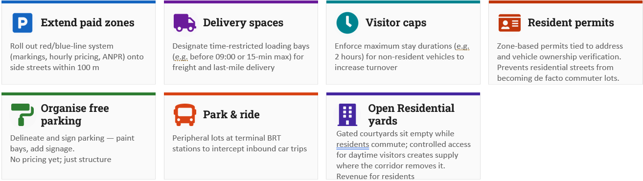
Figure 2 - Summary of the mitigation measures
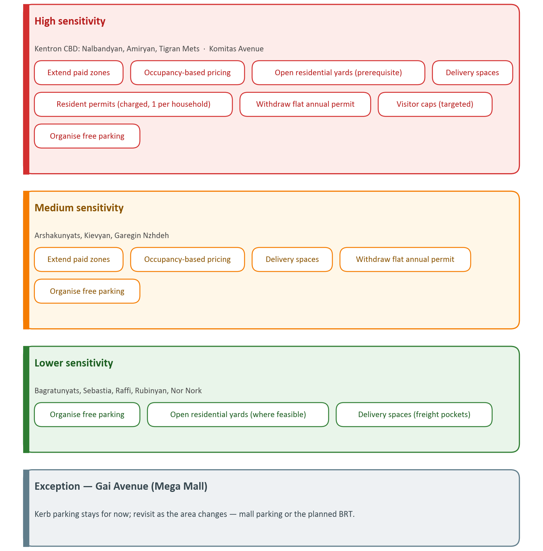
Figure 3 - Mitigation measures grouped by sensitivity zones

Figure 11. The map of sensitivity zones throughout the BRT corridors

Conclusions (and Next Steps)

Key Conclusions
- Parking loss is substantial and inherent to the design. On the v2 conceptual design the cross-section removes 4,875 of the 6,095 on-corridor on-street spaces on Corridors 1 and 2 (80%), retaining or re-establishing 1,220, consistent with the Mott MacDonald (2022) strategy and the Yerevan Sustainable Urban Transport Strategy. The loss follows from reallocating the full cross-section rather than from the median alignment as such: kerb-aligned sections remove as much kerbside parking as median-aligned ones. Corridor 3 is withheld pending its conceptual design, and these figures will be updated when the design is final.
- Impacts are highly differentiated by zone. The Kentron CBD and Komitas Avenue face the highest pressure — 138% and 123% peak occupancy, with only 10% and 0% of displaced demand re-absorbable on nearby streets — and Komitas is reclassified from medium to high sensitivity on that evidence. Mid-corridor arterials face moderate pressure; outer residential segments require lighter-touch reorganisation.
- Yerevan has strong enabling infrastructure. ANPR-based enforcement, the red-line registry, PCS CJSC's digital payment ecosystem, and existing municipal authority provide a credible foundation for scaling up a reformed parking regime.
- Mitigation must be layered, not singular. No single measure resolves displacement. The recommended package combines paid-zone expansion with occupancy-based tariffs, withdrawal of the flat annual permit, charged one-per-household resident permits, loading bays sized to the measured freight pockets, organised free parking, the opening of residential yards, targeted visitor caps and a route for removing derelict vehicles — applied selectively by sensitivity zone, with the yard opening as the prerequisite the arithmetic depends on.
- Resident permits are charged, capped and transitional. One permit per household, priced at a modest annual fee rather than issued free, is what keeps the scheme from re-creating the zero-priced kerb it is meant to replace. The resident rate should converge on the standard tariff as public-transport and non-motorised modal shares rise.
- Enforcement and modal shift underpin demand reduction, but all measures are complementary. Strong enforcement and a credible public transport alternative are the foundation of any successful parking reform, yet they do not operate in isolation. Paid-zone expansion, resident permits, loading bays, visitor caps and yard opening each address a distinct facet of the displacement problem, and their effectiveness depends on being deployed as an integrated package rather than as standalone interventions.
- The demand side is now measured, not inferred. A targeted field occupancy survey of six representative areas recorded capacity-weighted peak occupancy of 93%, a short-stay, high-turnover kerb (about 63% of stays one hour or less; turnover 3.5 to 7.5 per space per day), and peak displaced demand equal to only 59% of the spaces removed (1,120 against 1,886). Aggregate re-absorption approaching 100% is achievable but conditional on opening the gated residential courtyards, which supply 83% of the absorptive capacity counted. The measured behaviour recalibrates the zoning: Komitas behaves as high-sensitivity and is reclassified, and Gai Avenue's kerb parking is left in place for now, to be revisited as the area develops.

Institutional Responsibility for Delivery
- The measures in this report have no single owner at present, and that is itself the first risk to implementation. Parking in Yerevan is governed by four bodies with distinct and non-overlapping powers: the Council of Elders sets tariffs and designates zones; the Municipality's Transport Department holds strategic coordination with public transport and the road network; Parking City Service CJSC executes operations, marking and ANPR enforcement; and the Road Police adjudicate violations and hold the towing power. No one of them can deliver the package alone, and none currently holds a mandate to sequence it against the corridor construction programme.
- The recommendation is therefore institutional before it is technical. The Municipality's Transport Department should be designated as the accountable owner of kerbside management for the corridor programme, with a standing kerb-management function — a small team, not a new agency — responsible for holding the measure sequence, commissioning the occupancy measurements that the tariff rule depends on, and reporting on delivery. The Project Implementation Unit should carry the coordination between that function and the corridor construction programme for the duration of the project, because the sequencing requirement is what fails if the two run independently.
- The table below assigns each measure to the body that must act and the instrument it requires. It is intended as the basis for a delivery agreement rather than as a description of current practice.
- Table 1 - Institutional responsibility for each measure
Measure | Accountable body | Instrument required
Extend paid zones onto cross-streets | Council of Elders (designation); Parking City Service (delivery) | Council decision on zone boundaries; marking and signage programme; ANPR coverage extension
Occupancy-based tariffs to the 85% target | Council of Elders | Tariff decision embedding an occupancy rule and a published review cycle
Withdraw the flat annual permit | Council of Elders; Parking City Service | Tariff decision; notice to existing holders; permit-uptake data release
Charged resident permits, one per household | Council of Elders (fee); Parking City Service (issue) | Permit regulation defining eligibility, the fee and address verification
Open residential yards (prerequisite) | Municipality Transport Department, with homeowners' associations | Feasibility and implementation study; standard municipal template; legal basis for courtyard ownership and revenue sharing
Delivery bays sized to the freight pockets | Municipality Transport Department; corridor design team | Incorporation into the detailed corridor design; time-restriction enforcement
Organise and delineate free parking | Parking City Service | Marking and signage programme
Visitor caps (targeted contingency) | Council of Elders; Parking City Service | Zone-specific maximum-stay rule
Remove derelict vehicles | Road Police, on referral from Parking City Service | Notice-and-removal procedure; municipal pound
Sequencing against construction | Project Implementation Unit | Delivery agreement with the Transport Department

Further Studies Required
The parking component of this project is scoped to the BRT corridors and their immediate influence area, but parking is inherently a citywide system and cannot be sustainably managed at corridor level alone. The measures proposed here should therefore be understood as the first stage of a broader reform. Consistent with the supply-led, spatially targeted methodology adopted for this assignment, follow-up work should extend the parking supply inventory beyond the corridor buffer to a citywide scale, apply focused demand assessments in selected high-pressure locations rather than corridor-wide observational surveys, and progressively expand the red-line zonal system into neighbourhoods currently outside it. Supporting studies on residential yard opening, the legal basis of the resident permit scheme, and willingness-to-pay will provide the empirical foundation for calibrating tariffs and guiding the phased citywide roll-out. The administration of residential-yard opening in particular — who should lead it and under what organisational and legal arrangement — warrants a dedicated study before any roll-out.

Sources

- "PARKING CITY SERVICE" • ARMENIA (YEREVAN) - SPYUR, https://www.spyur.am/en/companies/parking-city-service/30258/
- Transport - yerevan.am, https://www.yerevan.am/en/transport-department/
- A new procedure of organization of paid car parking will be operated in the capital since July 1 - yerevan.am | Official website, https://www.yerevan.am/en/news/a-new-procedure-of-organization-of-paid-car-parking-will-be-operated-in-the-capital-since-july-1/
- Yerevan to Nationalize Parking Management Firm, https://anca.org/yerevan-to-nationalize-parking-management-firm/
  - The FOICA vs. the "Parking City Service" CJSC - Court cases - Strategic litigation - Freedom of Information Center of Armenia., https://old.foi.am/en/all-cases/item/1315/
- Problems of Machine Processing of Personal Data in Armenia, https://mdi.am/en/archives/1611
- New tariffs for parking on the "red lines" in Yerevan were introduced ..., https://arka.am/en/news/society/new-tariffs-for-parking-on-the-red-lines-in-yerevan-were-introduced-to-relieve-the-center-explanatio/
- Mobile - PanARMENIAN.Net, https://panarmenian.net/m/eng/news/329255
- Court suspends decision raising parking fees in Yerevan - Arminfo, https://arminfo.info/full_news.php?id=92100&lang=3
- ANPR for Smart Parking Management: How It Works - Intozi, https://intozi.io/anpr-smart-parking-management/
- Official website | Municipality - yerevan.am, https://www.yerevan.am/en/staff/
- Parking in Yerevan - Repat Armenia, https://www.repatarmenia.org/repatriate/practical-information/first-steps-after-your-move/parking-in-yerevan
- Sustainability Developements in Armenia | Chambers Expert Focus, https://chambers.com/legal-trends/armenias-quest-for-green-e-mobility
- The Court of Appeal upheld the decision to deem the "red lines ..., https://www.amnews.am/language/en/social-eng-267/
- Vahan Kerobyan proposes to raise parking fees in Yerevan - Finport.am, https://finport.am/full_news.php?id=45957&lang=3
- Court halts parking fee hike in Yerevan - PanARMENIAN.Net - Mobile, https://panarmenian.net/m/eng/news/323133
- New Paid Parking Zones in Central Yerevan: What Drivers Need to ..., https://homycars.com/blog/new-paid-parking-zones-in-yerevan
- Guide to AI ANPR Parking Enforcement Solution in 2025 - Milesight, https://www.milesight.com/security/blog/ai-anpr-and-parking-enforcement
- Enabling smart parking for smart cities using Internet of Things (IoT) and machine learning - PeerJ, https://peerj.com/articles/cs-2544.pdf
- ANPR Car Park System: how it works and benefits - Tattile: Hi-Performance Mobility Solutions & AI software for ANPR, ALPR cameras, https://www.tattile.com/anpr-car-park-system/
- How to Do a Parking Study – MAPC - Metropolitan Area Planning Council, https://www.mapc.org/resource-library/how-to-do-a-parking-study/
- Official website | Electronic services - yerevan.am, https://www.yerevan.am/en/e-service/
- Municipality parking charging me hourly for long term parking : r/armenia - Reddit, https://www.reddit.com/r/armenia/comments/1p5f355/municipality_parking_charging_me_hourly_for_long/
- Odyssey with "Parking City Service" continues: Yerevan Municipality issued new explanations regarding the change in the amount of payment for parking via SMS | Finport.am, https://finport.am/full_news.php?id=30577&lang=3
- Garage Parking Analytics: Key Metrics for Parking Garage Managers - Neighbor Blog, https://www.neighbor.com/storage-blog/key-parking-analytics-for-parking-managers/
- Using Parking Analytics to Optimize Capacity Planning - Parking Guidance Systems, https://parkingguidancesystems.com/using-parking-analytics-to-optimize-capacity-planning/
- Estimating on-street parking occupancy using smart meter data - arXiv.org, https://arxiv.org/html/2106.02270v2
- Model for Determining Parking Demand Using Simulation-Based Pricing - MDPI, https://www.mdpi.com/2076-3417/15/12/6603

